**Pattern recognition of Characters 4, A, 8, B**

**Pattern Recognition process:**

1. Digitizing the character by a digital camera
2. Convert the character image to two dimensional binary array for pattern recognition process
3. Normalize the binary image to the size of 30 pixels height and 25 pixels of width(**Size Normalization**)
4. Apply **Zhang-Suen Skeletonization** to skeletonize the binary image
5. Extract features from the skeletonized binary image

**Features extracted**

1. Start/ end pixels
2. Intersection points
3. Horizontal lines
4. Vertical lines
5. Number of Holes
6. Left diagonals
7. Right Diagonals
8. **Image 4 (Standard Computer Image )**
9. **Input**: Image 4 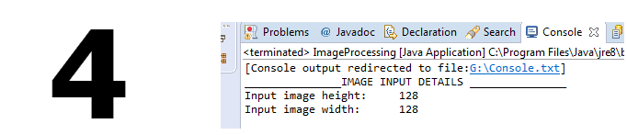
10. **Size Normalization**: Output: Image after converting to binary and size normalization

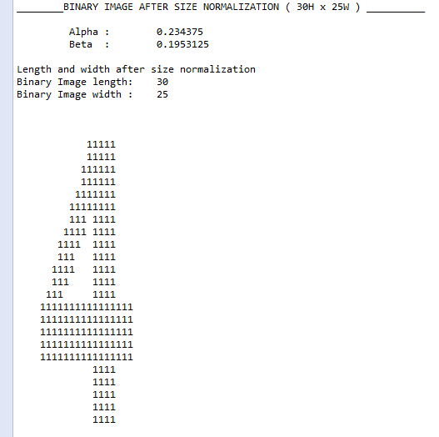

1. **Skeletonization**: Image after **Zhang-Suen Skeletonization**

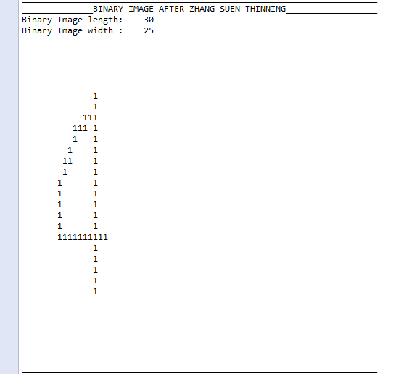

1. **Feature Extraction and classification**: Features extracted from Skeletonized image and

Image Classification

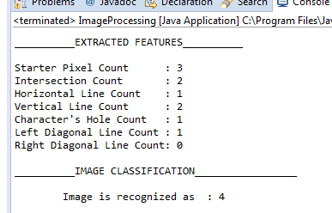

1. **Image ( Hand written 4 )**
2. **Input**: Hand written Image 4

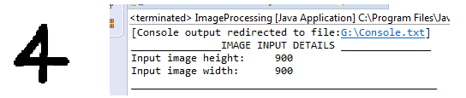

1. **Size Normalization**: Output: Image after converting to binary and size normalization

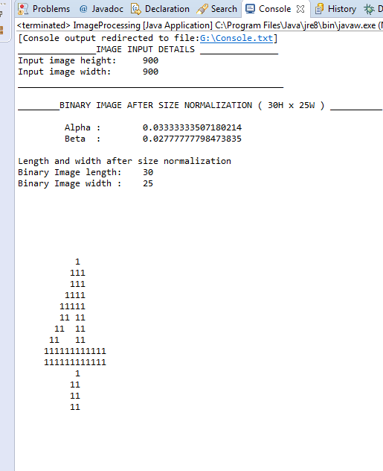

1. **Skeletonization**: Image after **Zhang-Suen Skeletonization**

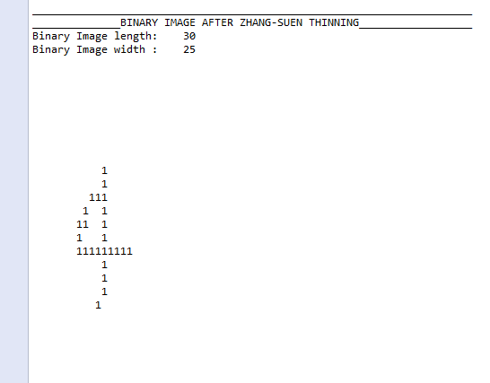

1. **Feature Extraction and classification**: Features extracted from Skeletonized image and image Classification

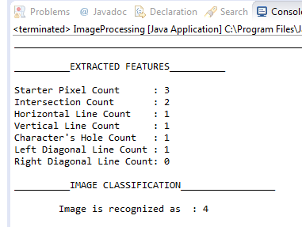

1. **Image ( Hand written 4 )**
2. **Input**: Hand written Image 4

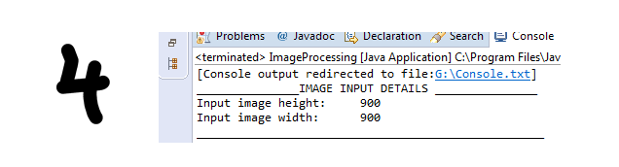

1. **Size Normalization**: Output: Image after converting to binary and size normalization

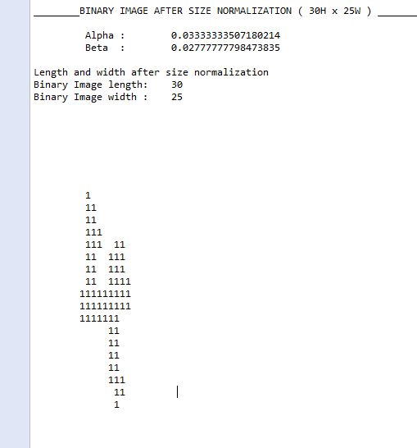

1. **Skeletonization**: Image after **Zhang-Suen Skeletonization**

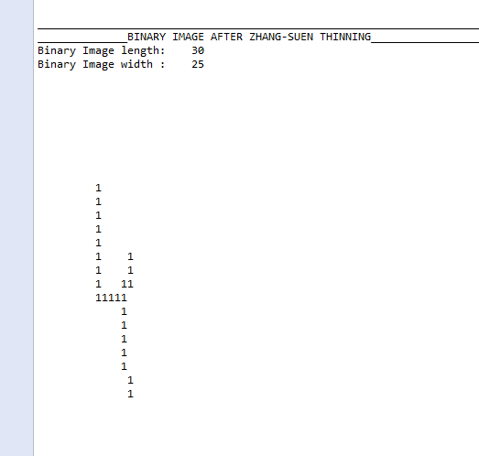

1. **Feature Extraction and classification**: Features extracted from Skeletonized image and image Classification

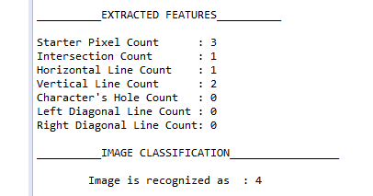

1. **Image (Standard Computer Image 8 )**
2. **Input**: Image 8

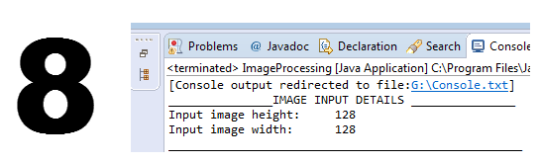

1. **Size Normalization**: Output: Image after converting to binary and size normalization

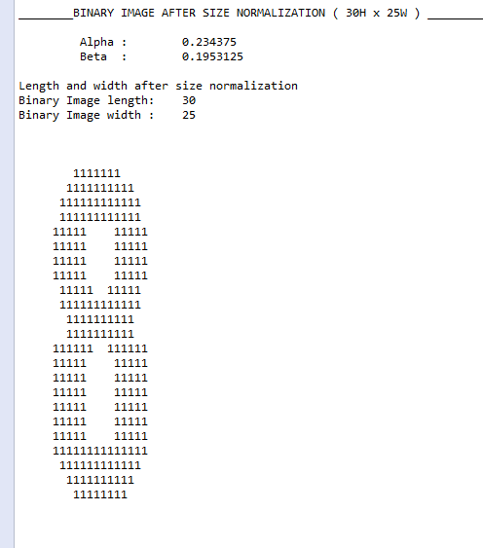

**Skeletonization**: Image after **Zhang-Suen Skeletonization**

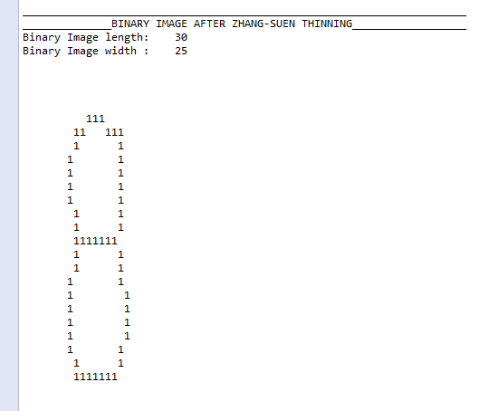

1. **Feature Extraction and classification**: Features extracted from Skeletonized image and image Classification

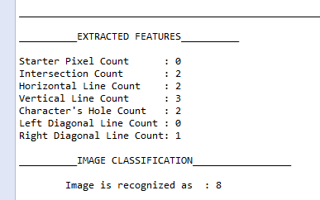

1. **Image ( Hand written Image 8 )**
2. **Input**: Image 8

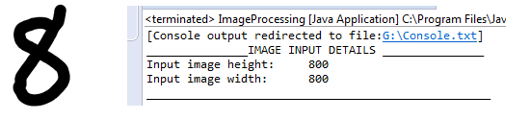

1. **Size Normalization**: Output: Image after converting to binary and size normalization

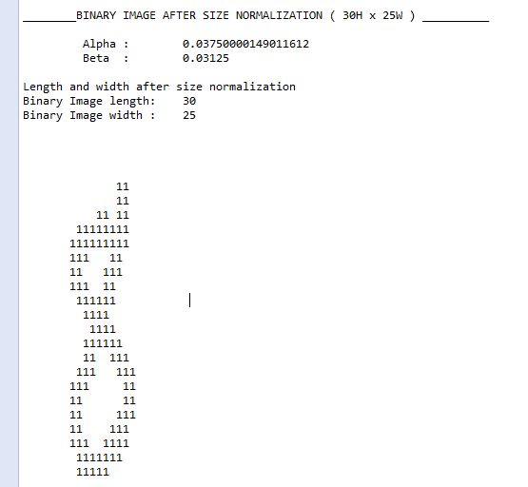

1. **Skeletonization**: Image after **Zhang-Suen Skeletonization**

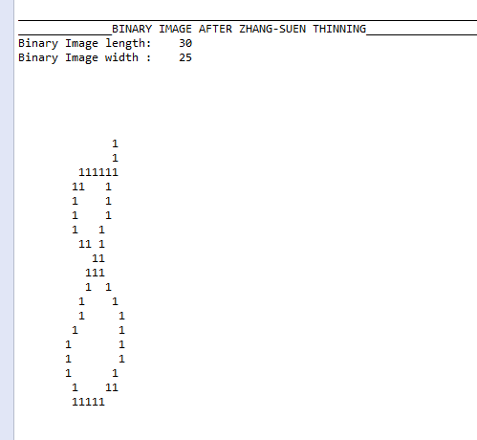

1. **Feature Extraction and classification**: Features extracted from Skeletonized image and image Classification

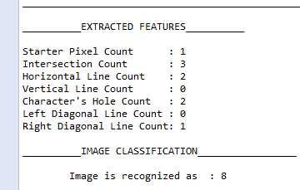

1. **Image ( Computer Input Image 8 )**
2. **Input**: Image A

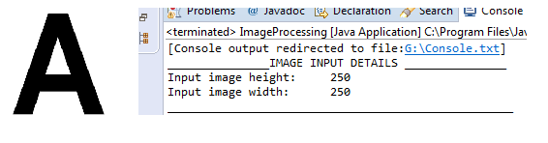

1. **Size Normalization**: Output: Image after converting to binary and size normalization

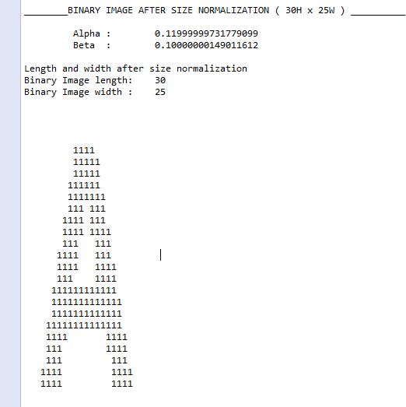

1. **Skeletonization**: Image after **Zhang-Suen Skeletonization**

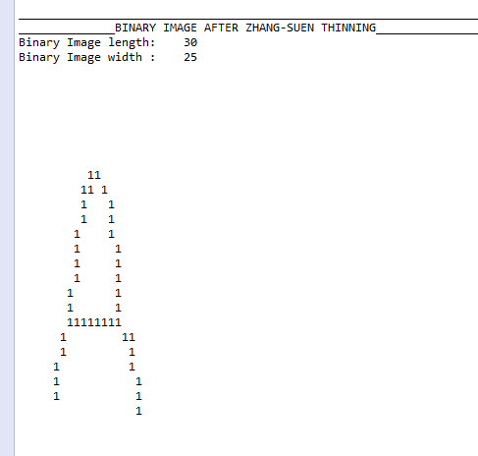

1. **Feature Extraction and classification**: Features extracted from Skeletonized image and image Classification

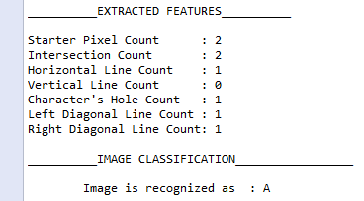

1. **Image ( Hand written Image A )**
2. **Input**: Image A

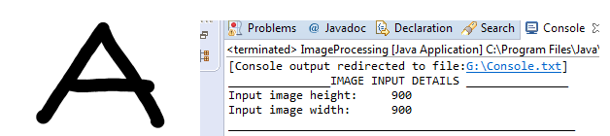

1. **Size Normalization**: Output: Image after converting to binary and size normalization

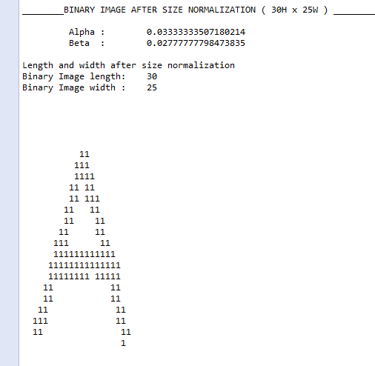

1. **Skeletonization**: Image after **Zhang-Suen Skeletonization**

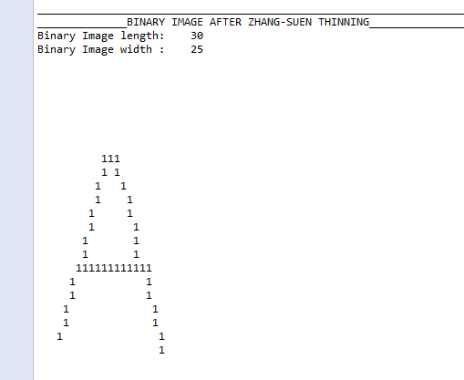

1. **Feature Extraction and classification**: Features extracted from Skeletonized image and image Classification

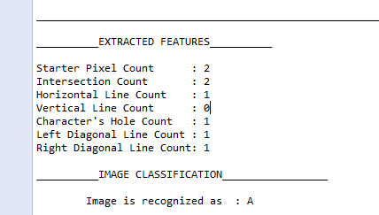

1. **Image ( Standard Computer input Image B )**
2. **Input**: Image B

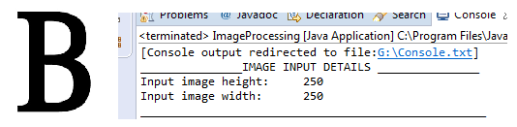

1. **Size Normalization**: Output: Image after converting to binary and size normalization

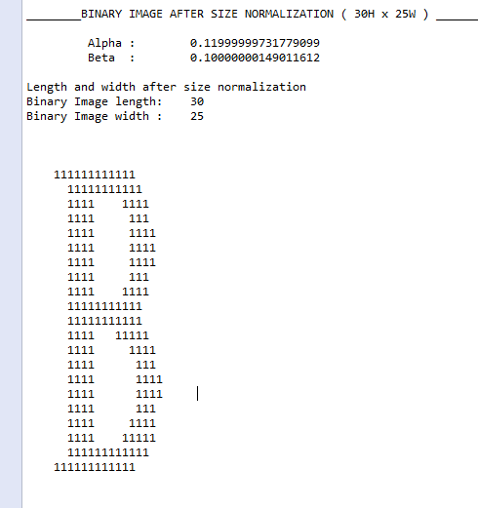

1. **Skeletonization**: Image after **Zhang-Suen Skeletonization**

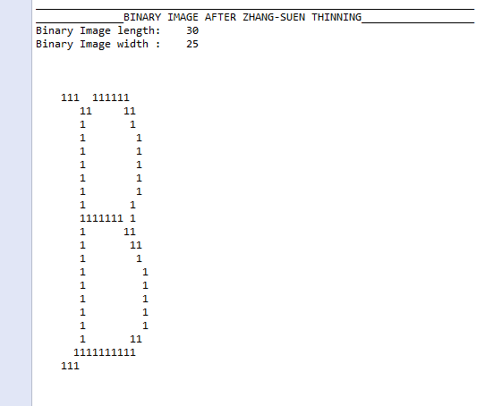

1. **Feature Extraction and classification**: Features extracted from Skeletonized image and image Classification

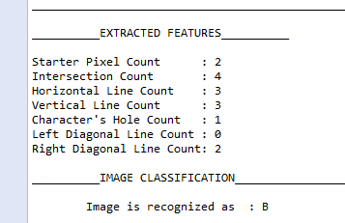

1. **Image ( Hand written input Image B )**
2. **Input**: Image B

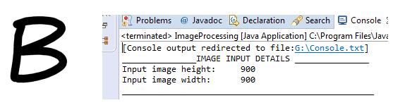

1. **Size Normalization**: Output: Image after converting to binary and size normalization

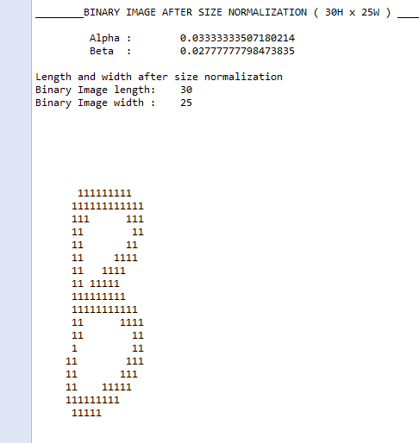

1. **Skeletonization**: Image after **Zhang-Suen Skeletonization**

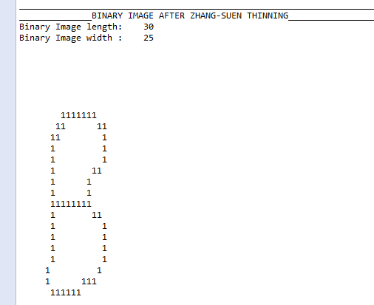

1. **Feature Extraction and classification**: Features extracted from Skeletonized image and image Classification

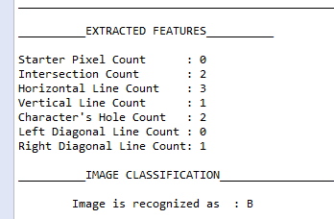

1. **Image (Hand written input Image B )**
2. **Input**: Image B

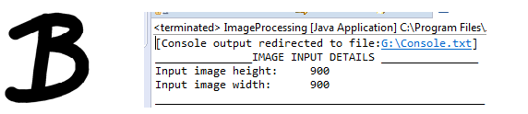

1. **Size Normalization**: Output: Image after converting to binary and size normalization

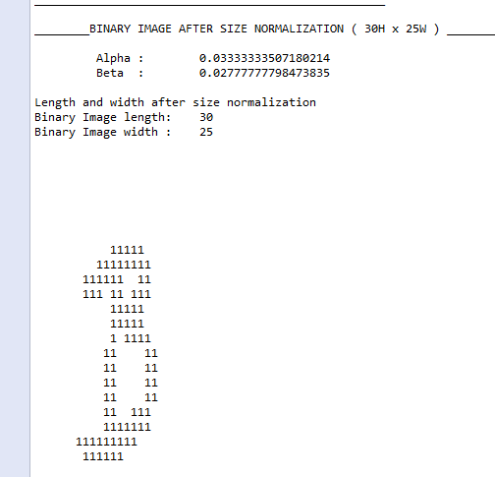

1. **Skeletonization**: Image after **Zhang-Suen Skeletonization**

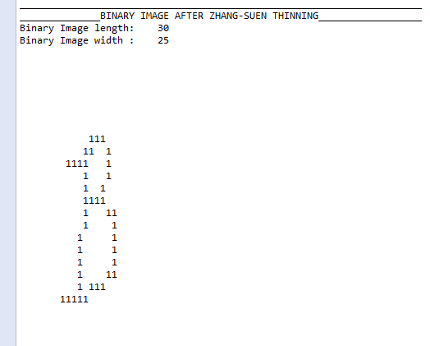

1. **Feature Extraction and classification**: Features extracted from Skeletonized image and image Classification

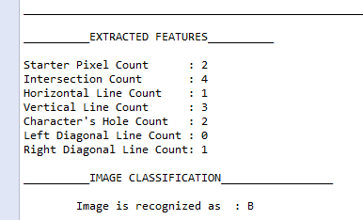

**Summary of Features classified according to the input images**

|  |  |  |  |  |  |  |  |
| --- | --- | --- | --- | --- | --- | --- | --- |
| **Features** | **Start/End pixels** | **Intersections** | **Horizontal lines** | **Vertical lines** | **No of Holes** | **Left diagonals** | **Right Diagonals** |
| **Images** |  |  |  |  |  |  |  |
| Computer Input Image 4 | **3** | **2** | **1** | **2** | **1** | **1** | **0** |
| Hand written Image 4 | **3** | **2** | **1** | **1** | **1** | **1** | **0** |
| Hand written Image 4 | **3** | **1** | **1** | **2** | **0** | **0** | **0** |
| Classifying features for Image 4 | **EXACT 3** | 1 to 2 | **EXACT 1** | 1 to 2 | 0 to 1 | 0 to 1 | **EXACT 0** |
|  |  |  |  |  |  |  |  |
| Computer Input Image 8 | **0** | **2** | **2** | **3** | **2** | **0** | **1** |
| Hand written Image 8 | **1** | **3** | **2** | **0** | **2** | **0** | **1** |
| Classifying features for Image 8 | 0 to 1 | 2 to 3 | **EXACT 2** | 0 to 3 | **EXACT 2** | **EXACT 0** | 0 to 1 |
|  |  |  |  |  |  |  |  |
| Computer Input Image A | **2** | **2** | **1** | **0** | **1** | **1** | **1** |
| Hand written Image A | **2** | **2** | **1** | **0** | **1** | **1** | **1** |
| Classifying features for Image A | **EXACT 2** | **EXACT 2** | **EXACT 1** | **EXACT 0** | **EXACT 1** | **EXACT 1** | **EXACT 1** |
|  |  |  |  |  |  |  |  |
| Computer Input Image B | **2** | **4** | **3** | **3** | **1** | **0** | **2** |
| Hand written Image B | **0** | **2** | **3** | **1** | **2** | **0** | **1** |
| Hand written Image B | **2** | **4** | **1** | **3** | **2** | **0** | **1** |
| Classifying features for Image B | 0 TO 2 | 2 TO 4 | 1 TO 3 | 1 TO 3 | 1 TO 2 | **EXACT 0** | 1 TO 2 |

**Observations:**